**Project Design Phase-II**

**Data Flow Diagram & User Stories**

|  |  |
| --- | --- |
| Date | 13 April 2025 |
| Team ID | SWTID1743517551 |
| Project Name | HOUSEHUNT – A HOUSE RENT APP |
| Maximum Marks | 4 Marks |

**Data Flow Diagrams:**

A Data Flow Diagram (DFD) is a traditional visual representation of the information flows within a system. A neat and clear DFD can depict the right amount of the system requirement graphically. It shows how data enters and leaves the system, what changes the information, and where data is stored.

**HOUSEHUNT – A HOUSE RENT APP DFDs:**

**Level-0 Description:**

In this diagram, Customer,

Landlords and System Administrator are entity sets.

Functions of Customer:

· New Registration

· Login Request

. Registration Confirmation by the System

· Reserve House

. House Issued by the System

. Email received for Reserved House.

Functions of System Administrator

· Add Customers/Tenants/landlords

· Send E-Mails for Reserved House

· View Transaction reports

. Post Vacant Houses

Functions of Landlord:

· Register in the system

· Post a New house

· Send House Confirmation to System Administrator

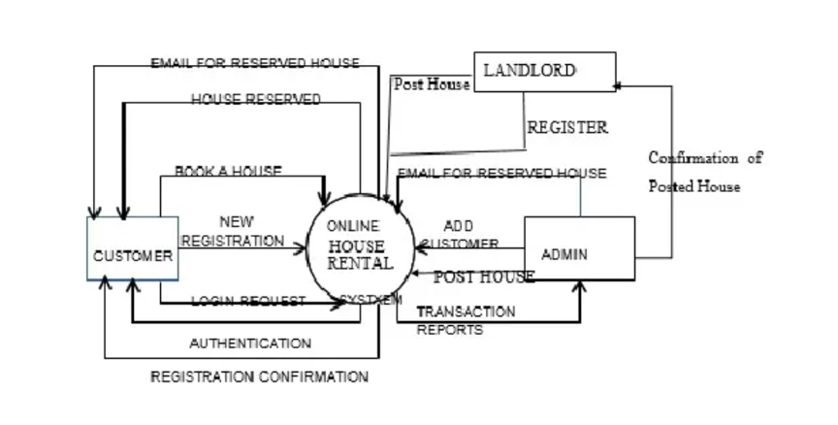

**LEVEL-1 DESCRIPTION:**

#### Customer

* **New Registration**: Customers register themselves as new users in the system.
* **Login Request**: Registered customers log in using their credentials.
* **Registration Confirmation by the System**: After successful registration, the system confirms and stores user details in the Customer DB.
* **Reserve House**: Customers browse available houses, choose a house, and initiate the rental process.
* **House Issued by the System**: Upon confirmation, the system reserves the selected house for the customer.
* **Email Received for Reserved House**: The customer receives an email confirmation for the reserved house.
* **Return & Feedback**: Customers can return the rented house and submit feedback.

#### Landlord

* **Register in the System**: Landlords register and log in to the system.
* **Post a New House**: Landlords can add details about new houses for rent.
* **Send House Confirmation to System Administrator**: Upon posting, confirmation is sent to the admin for review and listing.

#### System Administrator

* **Add Customers/Tenants/Landlords**: Admin has the authority to add and manage user profiles including customers and landlords.
* **Send E-Mails for Reserved House**: Admin sends out confirmation emails for house reservations.
* **View Transaction Reports**: Admin can view reports from Customer DB, Landlord DB, and House DB.
* **Post Vacant Houses**: Admin can approve and post new house listings submitted by landlords.

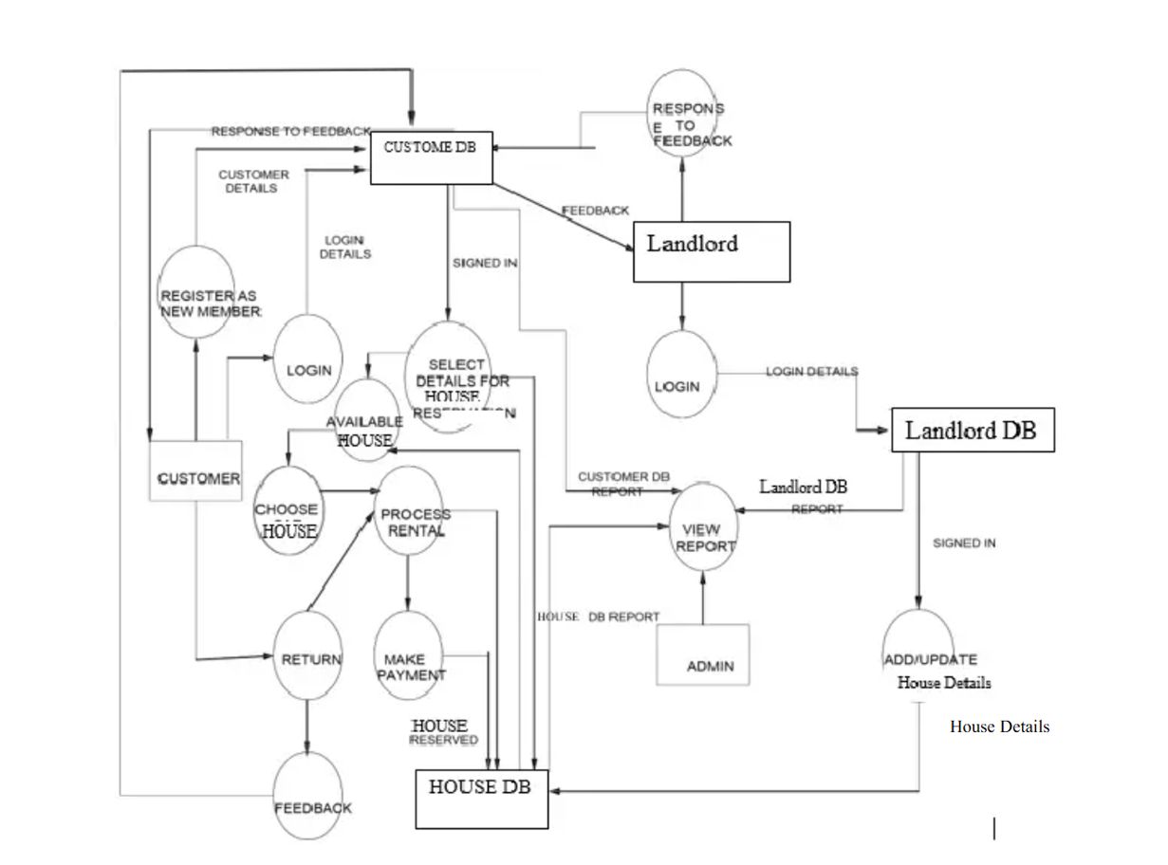

**User Stories**

Use the below template to list all the user stories for the product.

|  |  |  |  |  |  |  |
| --- | --- | --- | --- | --- | --- | --- |
| **User Type** | **Functional Requirement** | **User Story Number** | **User Story** | **Acceptance Criteria** | **Priority** | **Release** |
| Customer (Web user) | Account Management | HRS 1 | As a user, I want to register as a new member to access rental services. | I can enter personal details and receive a registration confirmation. | High | Sprint 1 |
| Customer (Web user) | Login | HRS 2 | As a user, I want to log in to my account. | I can enter credentials and access my dashboard. | High | Sprint 1 |
| Customer (Web user) | House Search & Selection | HRS 3 | As a user, I want to browse and choose houses based on my preferences. | I can filter/search available houses and see matching results. | High | Sprint 1 |
| Customer (Web user) | Reservation | HRS 4 | As a user, I want to reserve a selected house. | I can confirm house details and receive reservation confirmation. | High | Sprint 2 |
| Customer (Web user) | Payment | HRS 5 | As a user, I want to make a payment after reserving a house. | I can enter payment details and receive a payment receipt. | High | Sprint 2 |
| Customer (Web user) | House Return & Feedback | HRS 6 | As a user, I want to return the rented house and leave feedback. | I can submit a return request and enter feedback. | Medium | Sprint 3 |
| Customer (Web user) | Notifications | HRS 7 | As a user, I want to receive notifications about reservation status. | I receive email/SMS/app updates after reservation. | Medium | Sprint 3 |
| Landlord (Web user) | Account Management | HRS 8 | As a landlord, I want to register and log in to manage my houses. | I can register/login and access my property dashboard. | High | Sprint 1 |
| Landlord (Web user) | Post New House | HRS 9 | As a landlord, I want to post a new house with details. | I can submit house details like address, rent, type, and availability. | High | Sprint 2 |
| Landlord (Web user) | Feedback View | HRS 10 | As a landlord, I want to view feedback from tenants. | I can access customer feedback from my dashboard. | Medium | Sprint 3 |
| Admin | User Management | HRS 11 | As an admin, I want to add and manage customer and landlord accounts. | I can create, update, and delete user accounts. | High | Sprint 1 |
| Admin | House Posting Approval | HRS 12 | As an admin, I want to approve and post landlord-submitted houses. | I can verify house listings and make them visible to customers. | High | Sprint 2 |
| Admin | Transaction Reports | HRS 13 | As an admin, I want to view reports of all transactions and reservations. | I can access user, landlord, and house reservation reports. | Medium | Sprint 3 |
| Admin | Send Notifications | HRS 14 | As an admin, I want to send emails for reservation confirmation. | I can trigger email notifications upon successful reservation/payment. | Medium | Sprint 3 |
| Customer (Web user) | Customer Support | HRS 15 | As a user, I want to contact support if I face issues with reservations. | I can raise a ticket, chat with support, or check FAQs. | Low | Sprint 4 |